Speleosports of various kinds

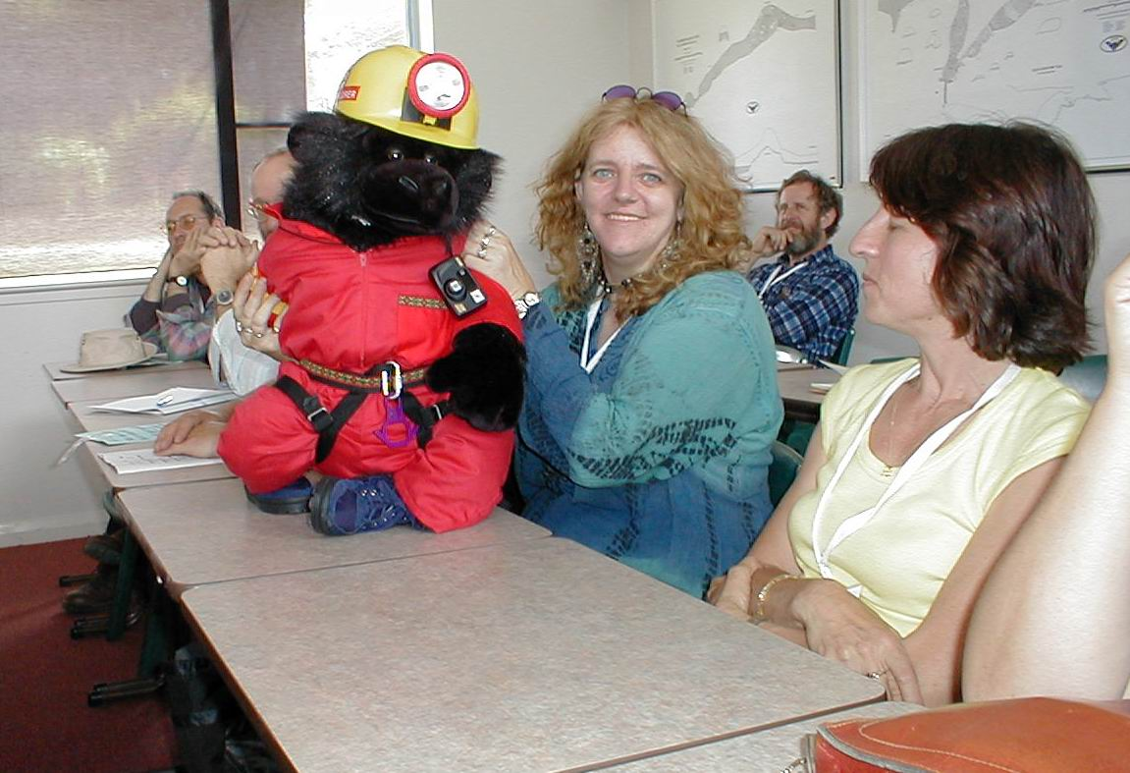
Marie Choi, Marie Horvath and mascot

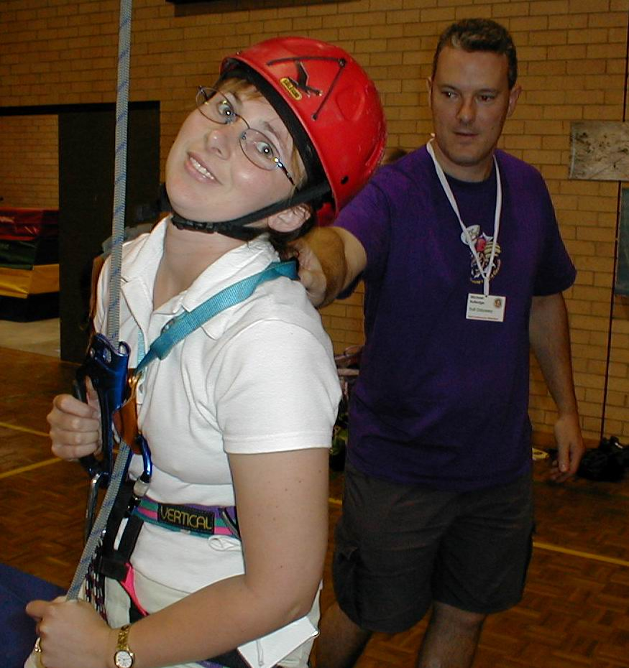
Prussiking Jodie (and Michael) Rutledge

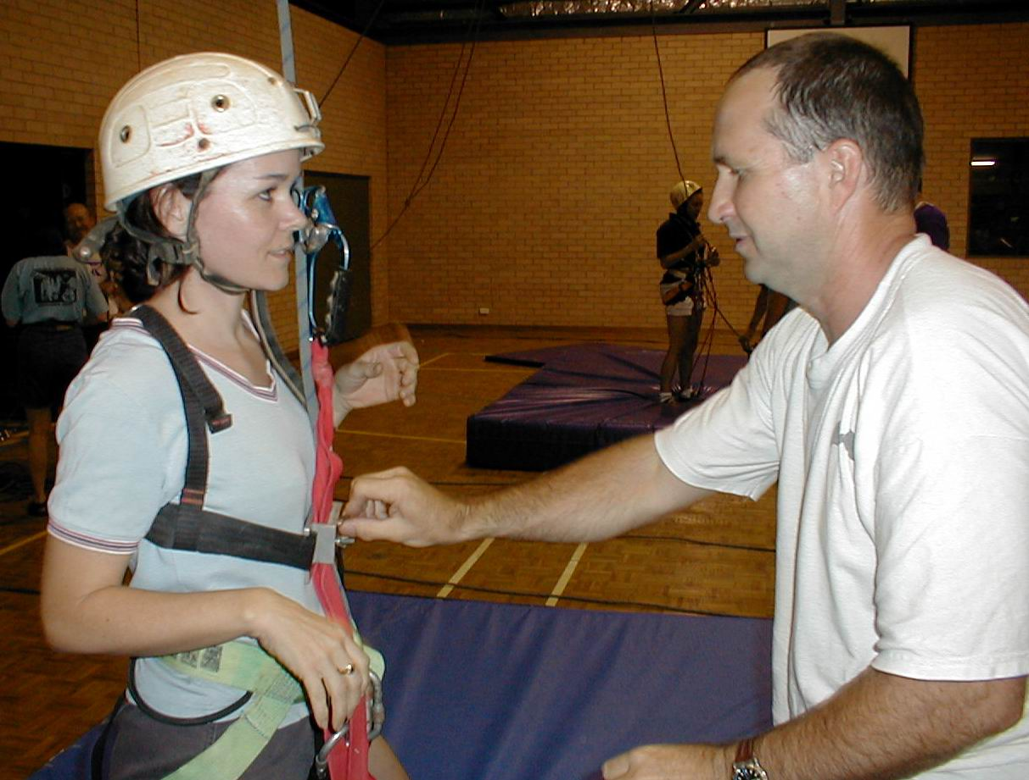
Pascale Levacher and Clive Kavanagh

All photos on this page by Arthur Clarke
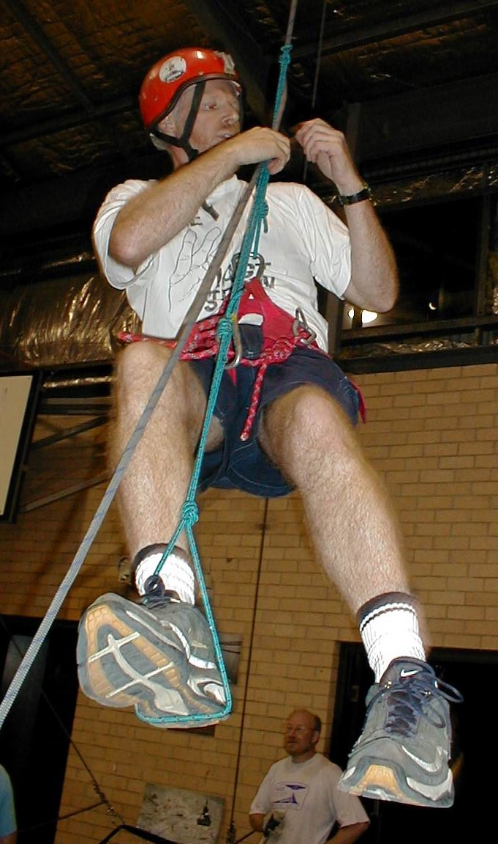
Phil Fleming using prussik knots

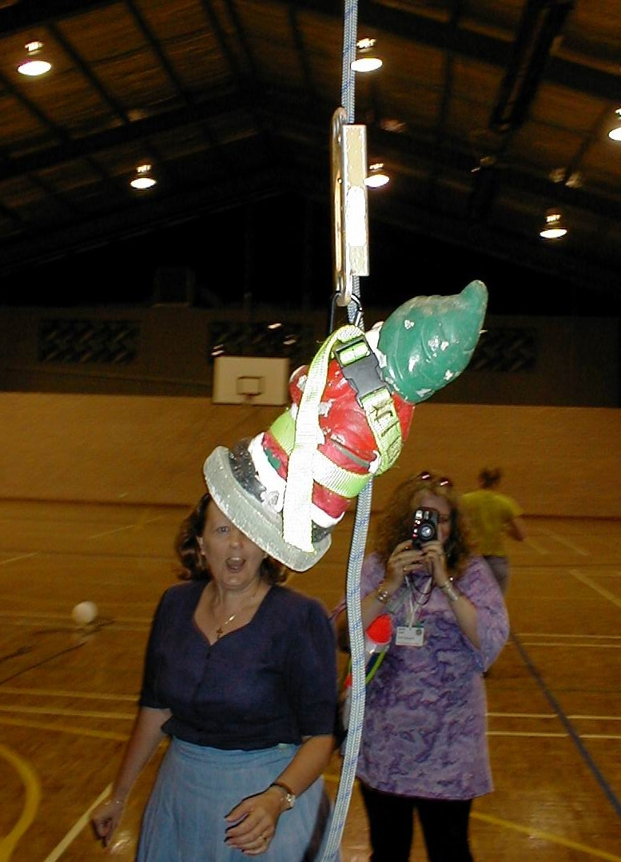
Vic Tim prussiking escape



